Passion for
Peak Performance

PRESENT:

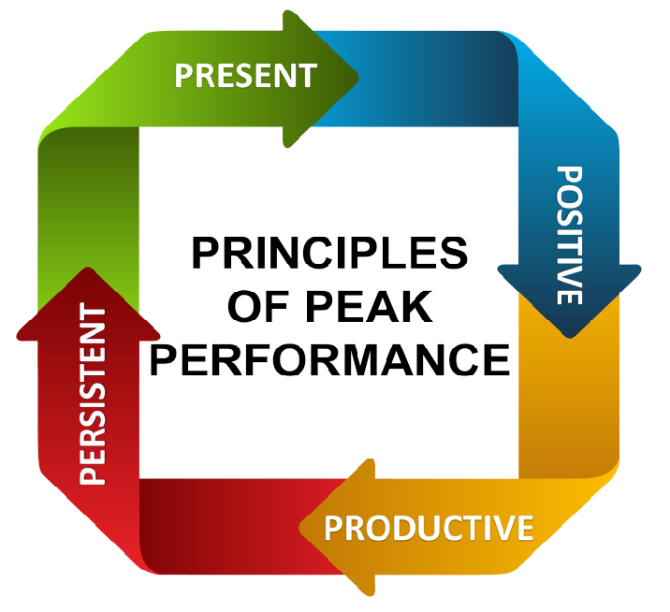
POSITIVE:

PRODUCTIVE:

PERSISTENT:

